

LANGUAGE TRANSLATOR

12.10.2022-18.10.2022

**Sprint 2**

Group 2

# INDEX

| **SL. NO.** | **CONTENTS** | **PAGE NO.** |
| --- | --- | --- |
| 1 | Overview. . . . . . . . . . . . . . . . . . . . . . . . . . . . . . . . . . . | 3 |
| 2 | Goals. . . . . . . . . . . . . . . . . . . . . . . . . . . . . . . . . . . . . . . | 3 |
| 3 | Purpose. . . . . . . . . . . . . . . . . . . . . . . . . . . . . . . . . . . . | 3 |
| 4 | Target audience. . . . . . . . . . . . . . . . . . . . . . . . . . . . . | 2 |
| 5 | Design overview. . . . . . . . . . . . . . . . . . . . . . . . . . . . .  DFD Level 0. . . . . . . . . . . . . . . . . . . . . . . . . . . . .  DFD Level 1. . . . . . . . . . . . . . . . . . . . . . . . . . . . .  Flowchart for client. . . . . . . . .. . . . . . . . . . . . . .  Flowchart for server. . . . . . . . . . . . . . . . . . . . . . | 4  4  5  6  7 |
| 6 | System architecture. . . . . . . . . . . . . . . . . . . . . . . . . .  Functions. . . . . . . . . . . . . . . . . . . . . . . . . . . . . . . | 8  8 |
| 7 | Tools report. . . . . . . . . . . . . . . . . . . . . . . . . . . . . . . . .  Make file. . . . . . . . . . . . . . . . . . . . . . . . . . . . Gcov report. . . . . . . . . . . . . . . . . . . . . . . . . . . ..  Gprof report. . . . . . . . . . . . . . . . . . . . . . . . . . . .  Splint report. . . . . . . . . . . . . . . . . . . . . . . . . . . . .  Valgrind report. . . . . . . . . . . . . . . . . . . . . . . . . . | 11  12  13  14 |
| 8 | Testing report. . . . . . . . . . . . . . . . . . . . . . . . . . . . . . .  Unit testing report. . . . . . . . . . . . . . . . . . . . . . .  Integration testing report. . . . . . . . . . . . . . . . . | 18  18  22 |
| 9 | Requirement Traceability Matrix. . . . . . . . . . . . . . . | 25 |

**Overview**

### Language Translator :

It is a language translator application in which the server has admin access where it can perform various functions like adding new language, adding meaning, modifying and deleting words in the database. The application then correlates this data and returns the respective translated words to the clients based on the input target and source language.

If the words are not present in the database then it gives the error message to the user that “words not found”.

Moreover, the application has the capability to generate files which have the information of various word meanings in different languages.

# Goals

This project aims at creating a language translator for a client having a required set of features. It aims at smooth functioning and connections between the client and server. All clients should be able to access certain functions.

# Purpose

The purpose of this document is to show the requirements for the language translator application, in which clients/users can get the desired translation of the word they provide.

# Target audience

The target audience are the clients who have the rights to translate their language. Also, the server has the authentication rights for themselves and can perform and manage various functionalities.

# Design Overview

Data Flow Diagram Level 0:

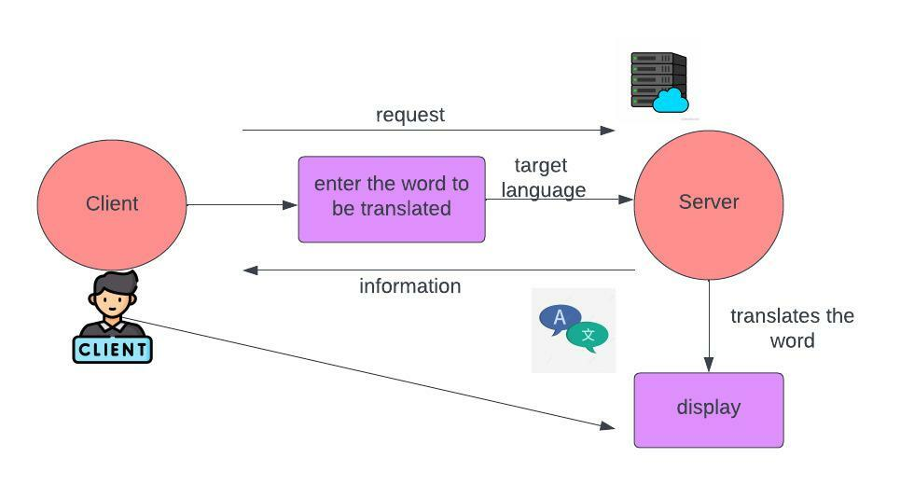

Data Flow Diagram Level 1:

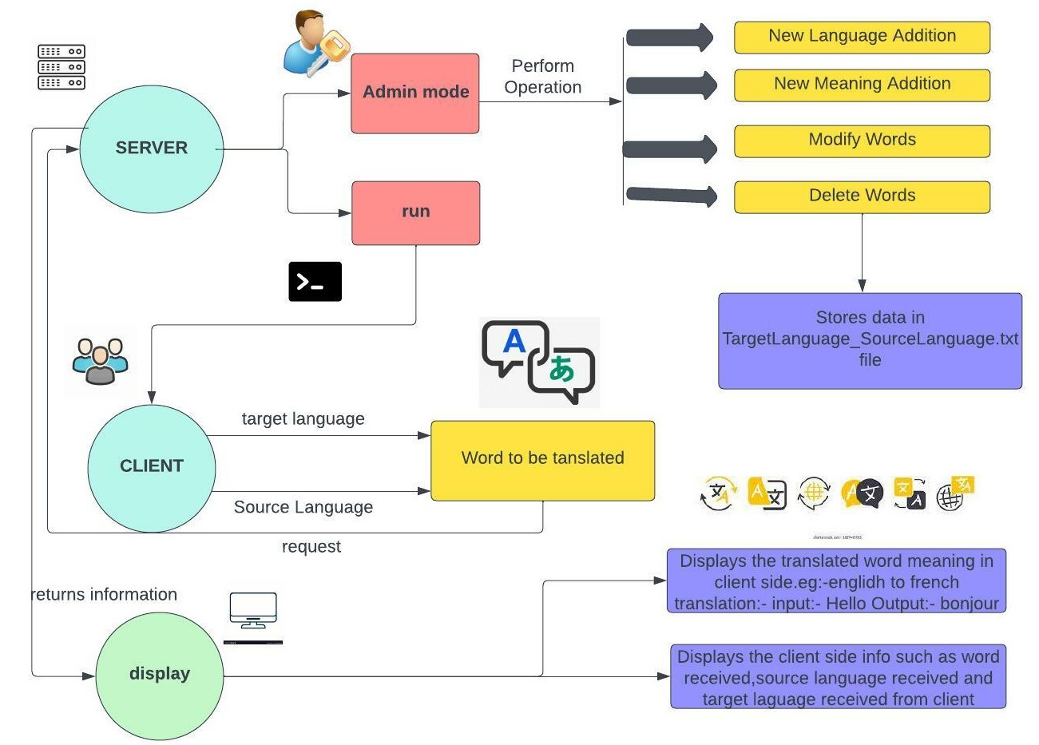

Flowchart for client:

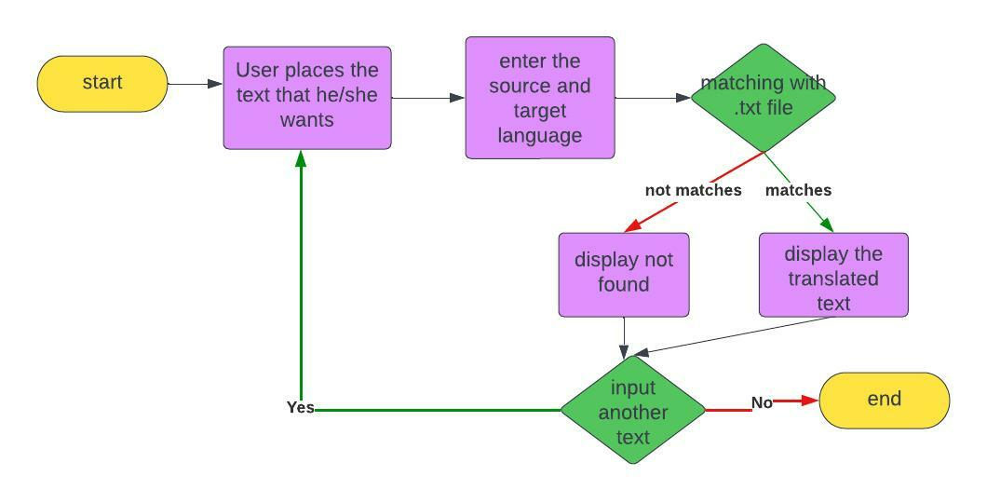

Flowchart for server:

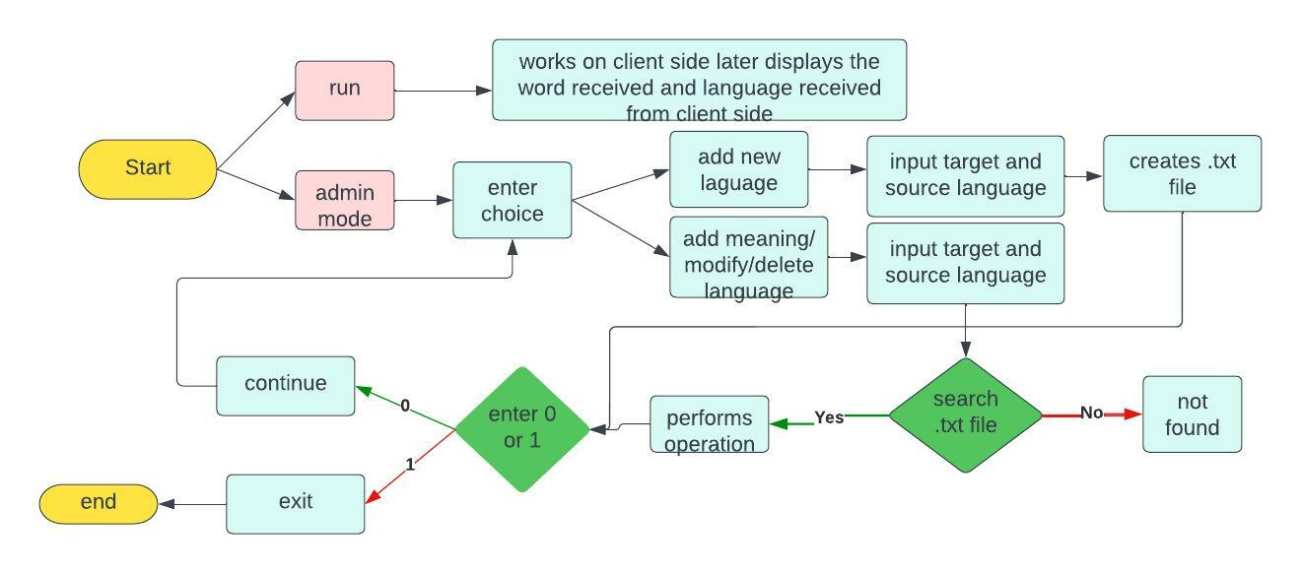

# System Architecture

Functions:

## SERVER FUNCTIONS:

**Server side authentication:**

Server program should start with an authentication

**translate():** When the client gives the input word, the target and source language, this function matches the word from the text file, if the word is available in the text file , it returns the word meaning.

**writeToFile():** This function is used to create new language and also add new meanings in the text file.

**modify():** This function is used to replace the meaning of the words that were incorrectly written previously.

**delete():** This function deletes the word meaning that is no longer required. It basically deletes the entire line containing that word and in the output screen displays the remaining contents of the text file.

## CLIENT FUNCTIONS:

### Client side program starting:

The user should start the client program to connect the Server whenever he wants.

### Client side connection request:

Client should request a connection to the server on port 8028

### 

### 

### Client side user environment:

The user is now ready to give the the word for the language conversion

### Client side quit:

The user uses the subcommand exit to terminate the connection.

# Tools Report

# MAKE FILE:

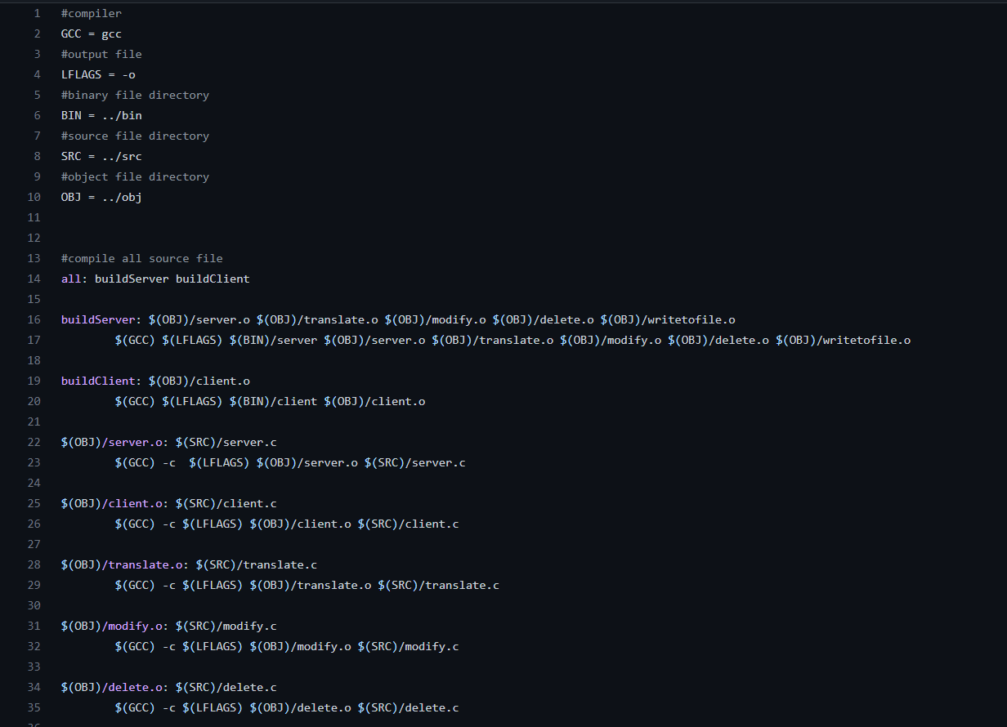

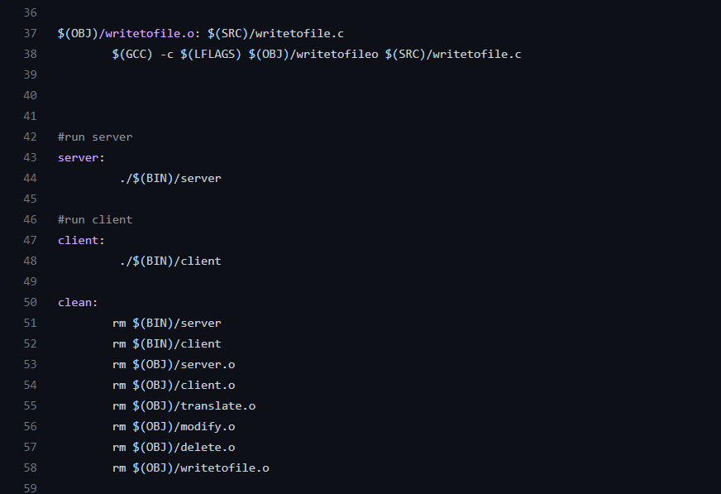

Gcov report:

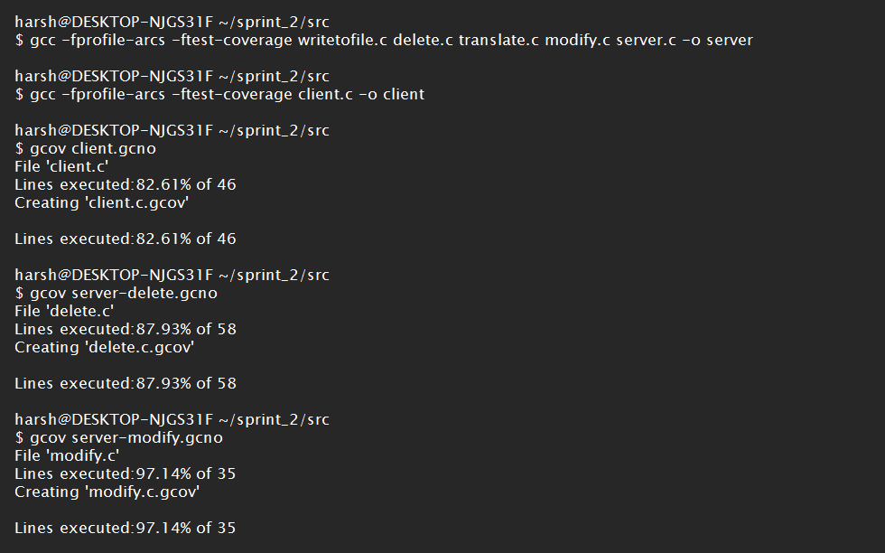

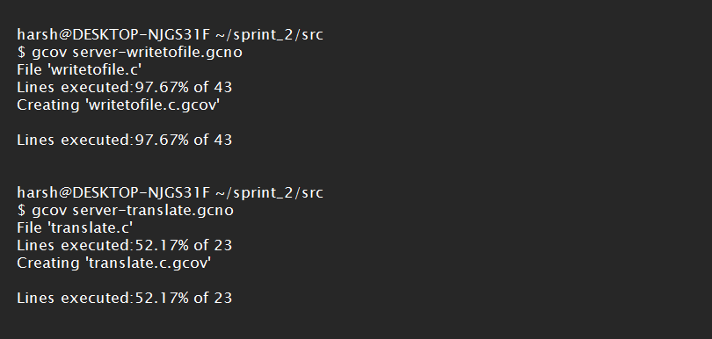

Gprof report:

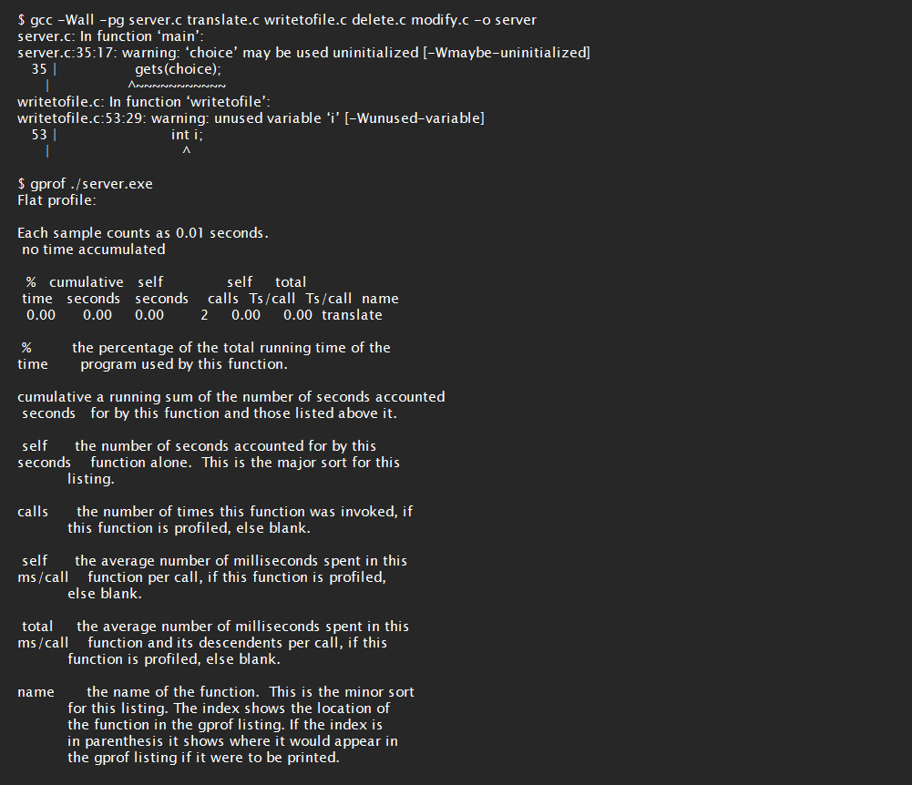

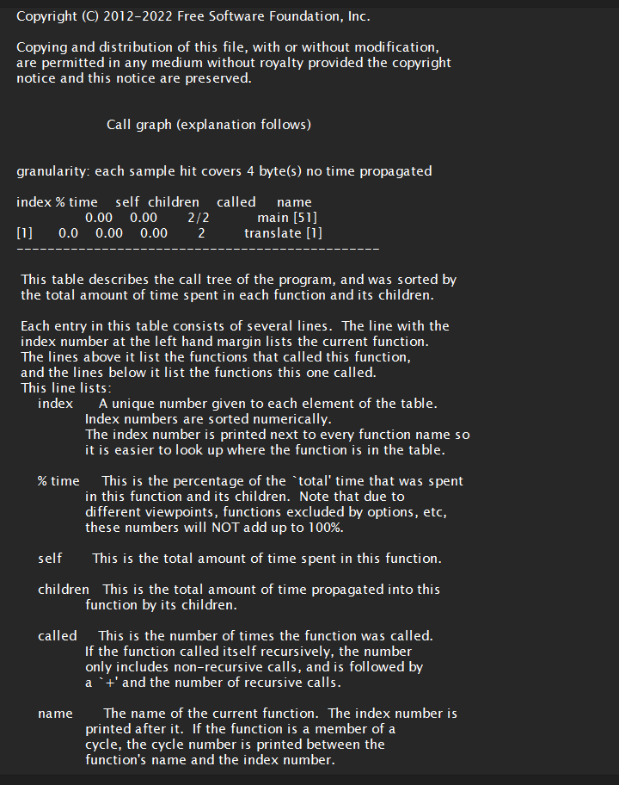

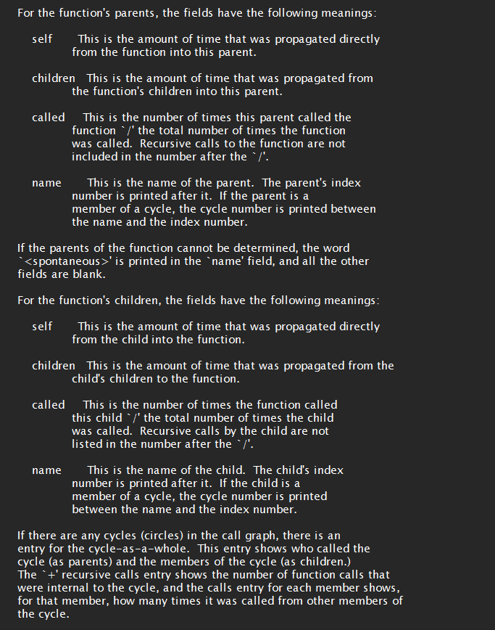

Splint report:

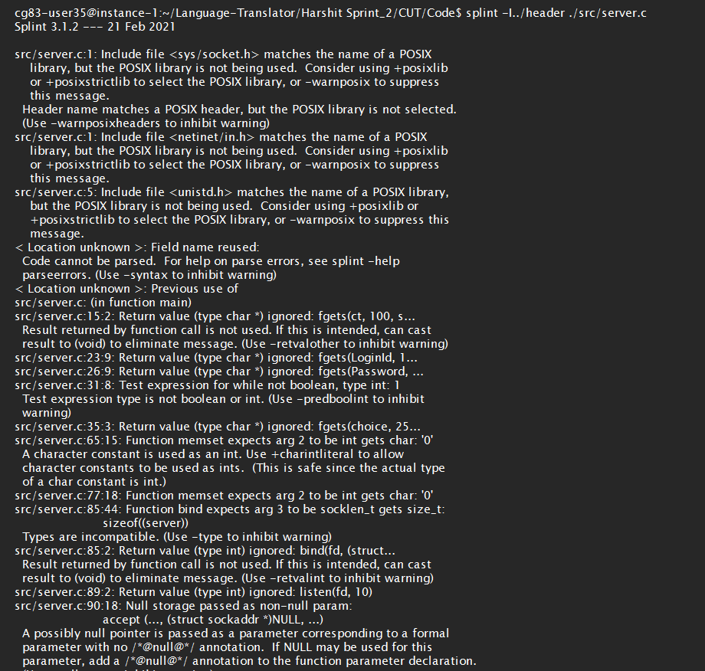

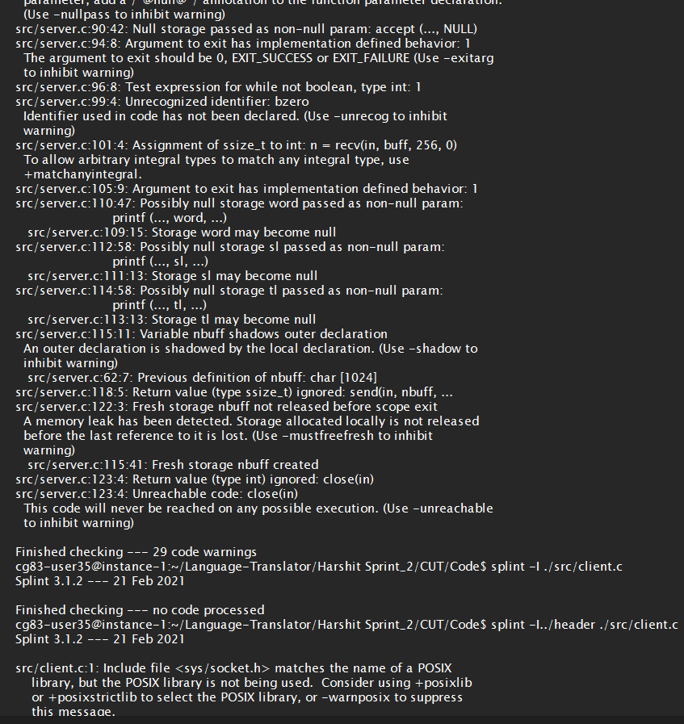

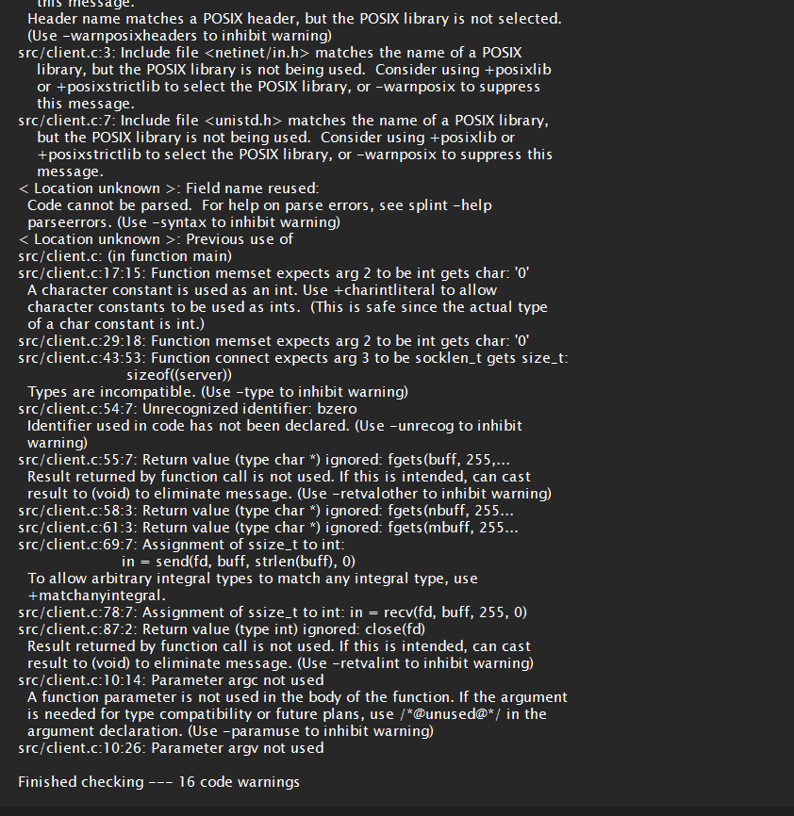

Valgrind report:

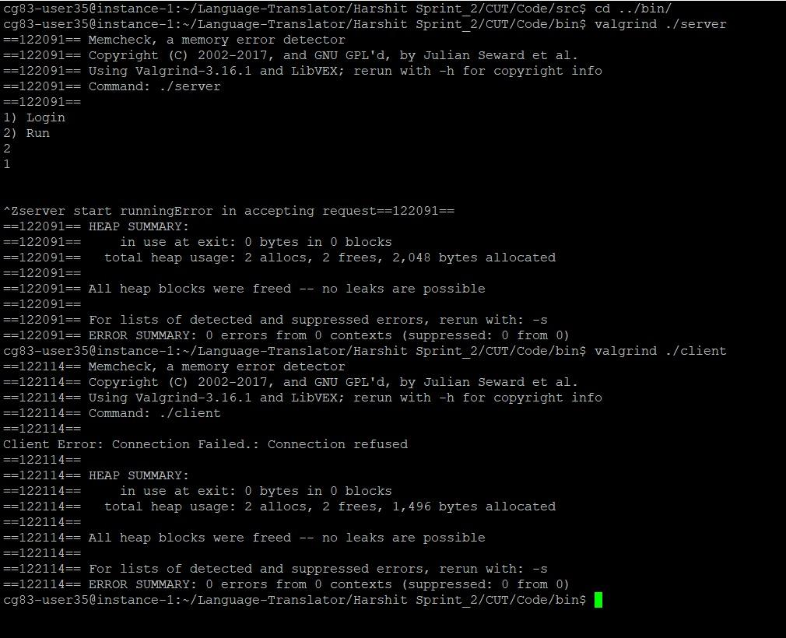

**UNIT TESTING**

1. For writetofile function:

Test_Case 1-6

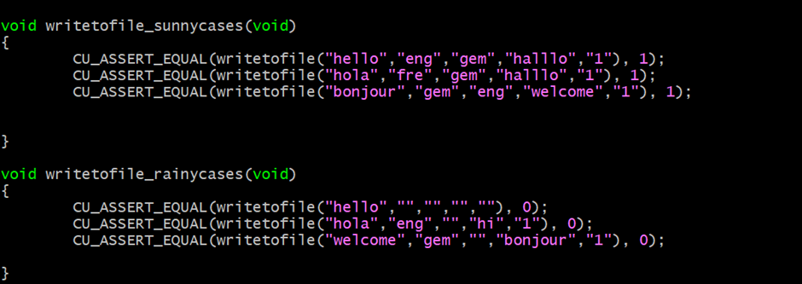

1. For modify() function

Test_Case 7-12

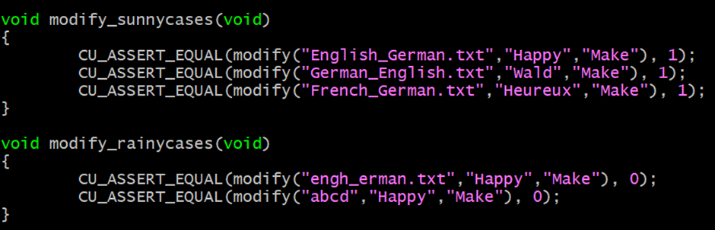

3.For delete() function

Test_Case 13-18

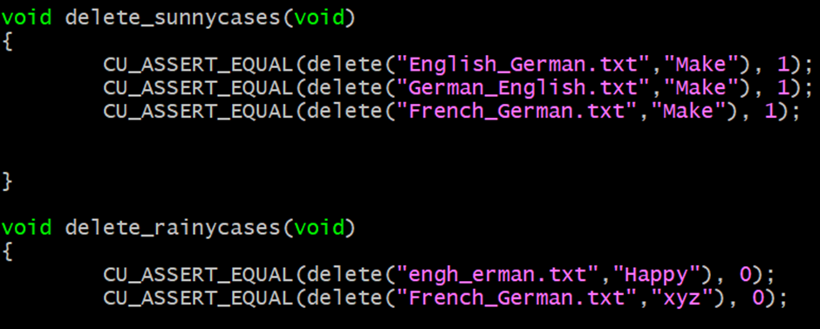

4.For translate() function

Test_Case 19-25

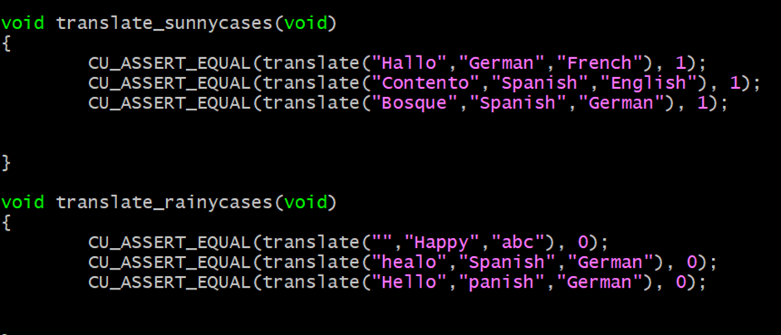

Output:

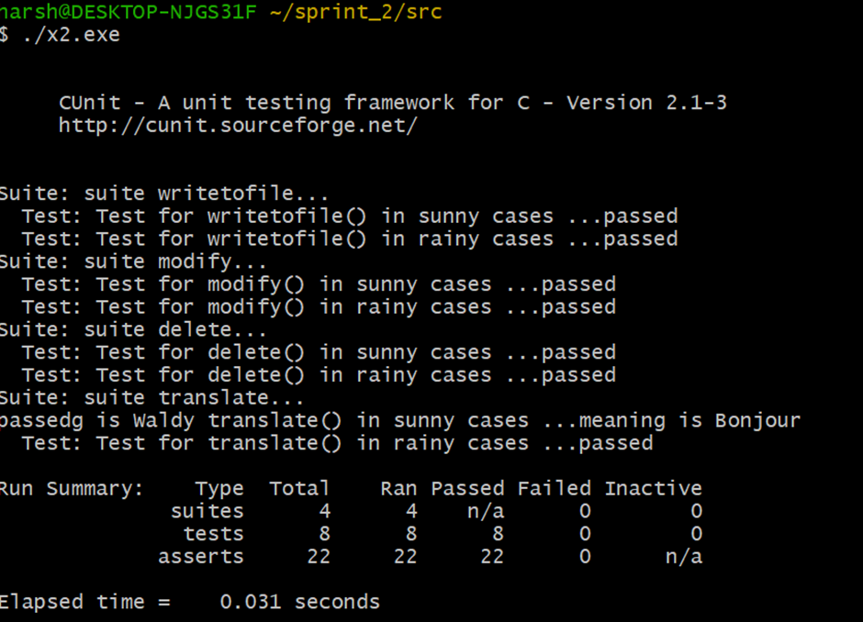

**INTEGRATION TESTING**

**IT_Case1: Running the Server - User Login**

## 

**IT_Case2: Add New Language**

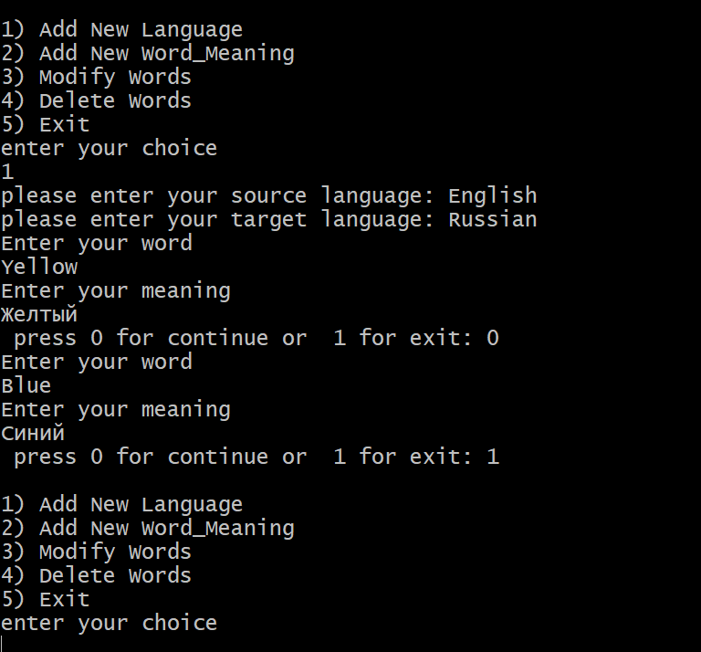

**IT_Case3: Add New Word_Meaning**

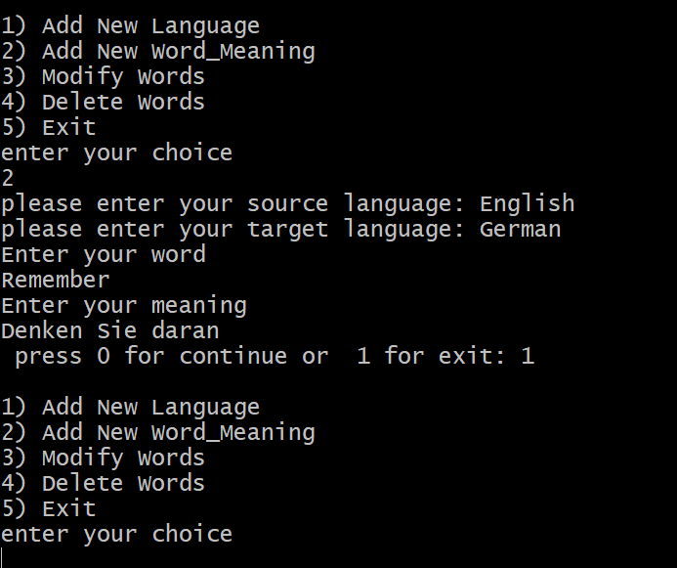

**IT_Case4: Modify Words**

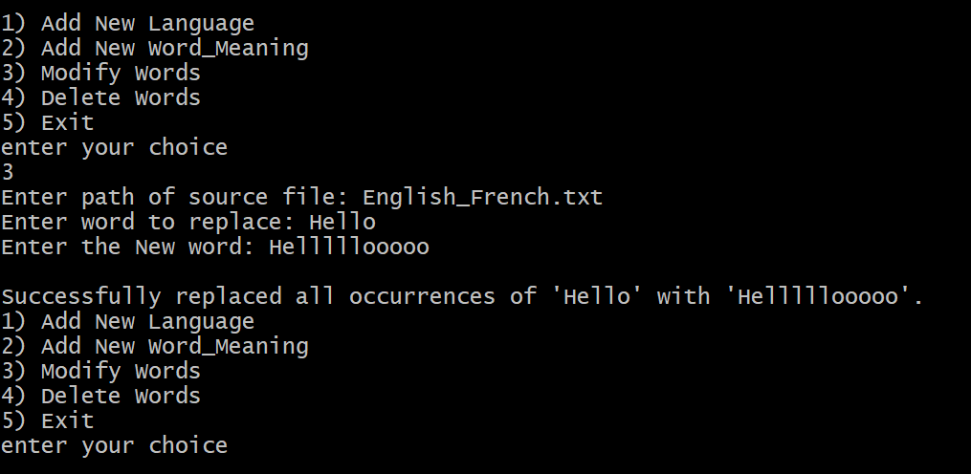

**IT_Case5: Delete Words**

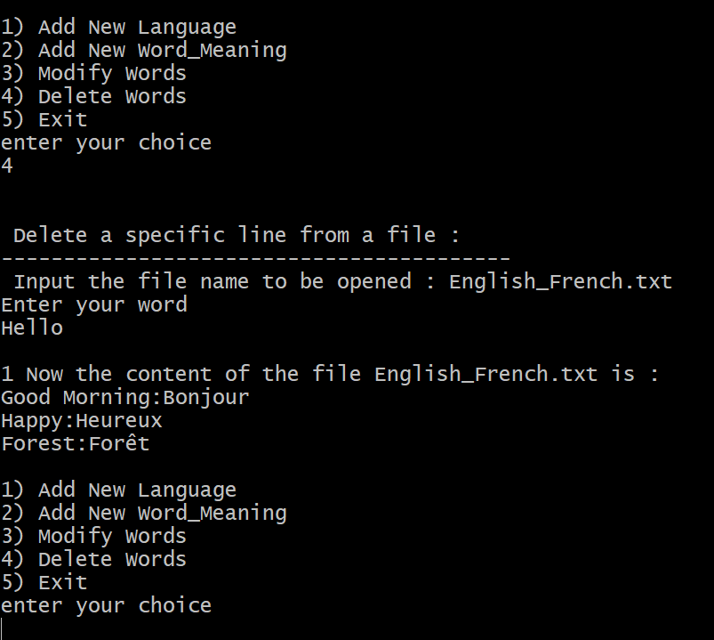

## **IT_Case6: Running the Client - Translator**

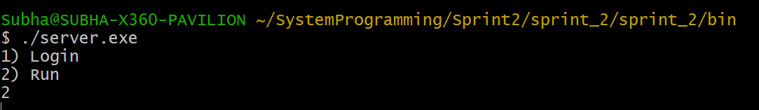

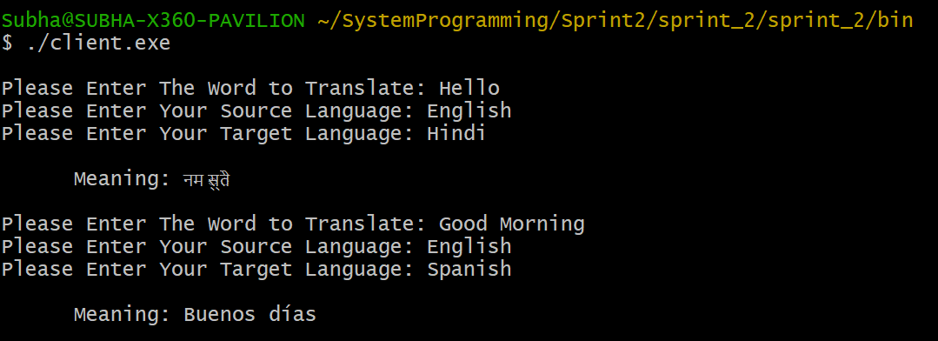

# Requirement Traceability matrix(RTM):

